**Information Technology – Grade 12**

**Standardised SQL Test 2016**

Name:

Use Account:

Password:

CommNews is a newspaper that was established last year. The newspaper has a classified section where companies can place adverts. A database called **NewspaperDB** is provided with tables containing the names of all their clients (**tblClients**), the details of the advertisements placed by clients (**tblAdverts**) and the tariff for each category of advert (**tblTariff**).

**Table design for tblAdverts**

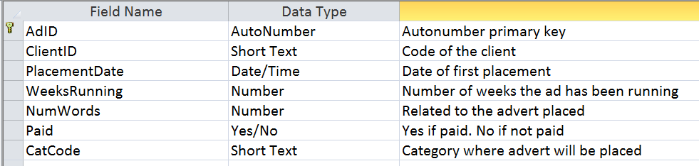

**Sample data for tblAdverts**

| **tblAdverts** | | | | | | |
| --- | --- | --- | --- | --- | --- | --- |
| **AdID** | **ClientID** | **PlacementDate** | **WeeksRunning** | **NumWords** | **Paid** | **CatCode** |
| 1 | PP001 | 2015-10-19 | 2 | 66 | Yes | Ani |
| 2 | DB002 | 2016-10-28 | 3 | 28 | No | Ani |
| 3 | BE013 | 2015-12-10 | 3 | 16 | Yes | Car |
| 4 | BE013 | 2016-10-10 | 3 | 25 | No | Car |
| 5 | CA012 | 2016-10-24 | 2 | 15 | No | Car |

**Table design for tblClients**

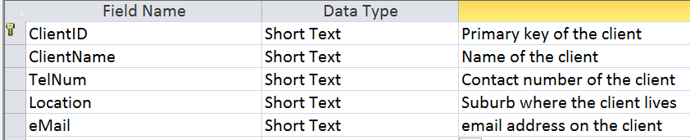

**Sample data for tblClients**

| **tblClients** | | | | |
| --- | --- | --- | --- | --- |
| **ClientID** | **ClientName** | **TelNum** | **Location** | **eMail** |
| BE013 | Best Cars | (011) 678 9883 | Bedfordview | best.cars@gmail.co.za |
| CA012 | CarSelect | (011) 098 3445 | Roodepoort | CarSelect@bmw.co.za |
| DB002 | DogBox | 082 123 3210 | Midrand | dogbox@dogs.org |
| DO007 | Dotty | (011) 285 9887 | Bedfordview | dotty@gmail.com |
| EC009 | EconoTravel | (011) 542 3438 | Johannesburg | econo@xx.co.za |

**Table design for tblTariff**

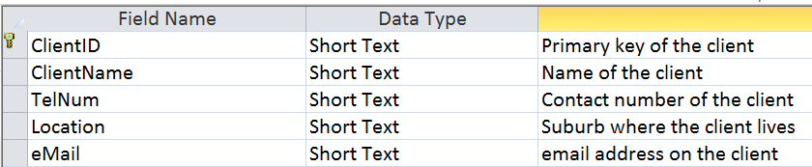

**Sample data for tblTariff**

| **tblTariff** | | |
| --- | --- | --- |
| **CategoryCode** | **CategoryName** | **Tariff** |
| ANI | Animals | 6.55 |
| CAR | Cars | 10.79 |
| COM | Computers | 10 |
| JOB | Jobs | 6.99 |

*Write SQL statements to do the following:*

1. Display all the client details from the tblClients table sorted by Location and then ClientName. (2)
2. Write a query that will display the details of all the adverts that were placed in the property section in 2015. Use the category code “PRO”. (3)
3. Display a list with the ClientName, email address, category code and placement date of any advert for clients located in Centurion. (4)
4. The number of words of all advertisements must be increased by one since each advert must contain a reference as part of the advertisement. Write a SQL statement to do this. (2)
5. Client PR010 wants to place all the ads they placed previously again as there were no responses to their ads. The adverts must be placed in the newspaper on 2016/05/02. They paid for the new placements. (6)
6. The editor wants a list with the all the details of all the adverts that were not placed in the newspaper yet. Write a SQL statement to list all adverts with a placement date in the future. (3)
7. The newpaper decided to award one of their clients with a weekend holiday. The client who placed an advert with the most number of words is the winner. Display the ClientId and NumWords of the winning client. (3)
8. CommNews wants to know the total income generated by the advertisements. Calculate the total income from all the adverts. Call the calculated field Total Income and display the value with the currency symbol rounded to two decimal places. (Currency is usually to two decimal places)  
    *Income per ad = number of words x category tariff x weeks running* (6)
9. The editor wants to know the number of ads in each category. He only wants to see the categories with more than 5 adverts per category. Display the category name and the total number of adverts for each category with more than 5 adverts. (6)
10. Write a query to display the advertisements that have above average number of words. (5)

**Total: 40**